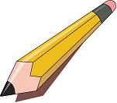Grade 4 Supply List

20 pencils
1 pencil case
1 package of crayons
2 packages of markers
1 package of pencil crayons
200 pages of looseleaf
2 composition books-can be found at the dollar store
6 duotangs (1yellow, 1black, 1green, 1blue, 1orange, 1red)
1 (2") binder
4 erasers
1 pair scissors
1 ruler
1 sketch book (dollar store)
1 small English dictionary (to be kept in student's desk)
1 glue stick
1 bottle of liquid glue
1 highlighter
1 pencil sharpener
1 roll of scotch tape
3 white board markers
1 backpack
Optional: Kleenex

