2014-15 Community Report for John MacNeil Elementary School
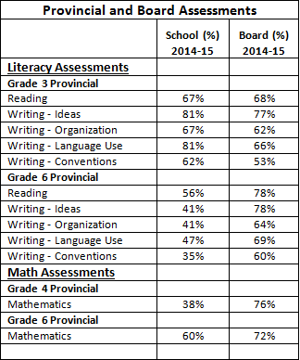
HRSB students participated in provincial and board-wide assessments. The information from these assessments helps us with our next steps in improving student achievement. We believe data from both the Provincial and Board assessments compliment the classroom data we collect. Our Continuous School Improvement (CSI) Plan will focus on reading comprehension with a stronger emphasis on small group instruction. Our math focus has been on problem solving for the last five years. This year, we can see a trend from the data where we need more work on number sense and in particular partitioning (breaking numbers apart). This year we have used the data to determine our next steps for improvement in comprehension and number sense. While we value the comparison between our students and the school board, it is the growth within our school that we truly value.

Even though our grade six students preformed under the board average, they have shown improvement against themselves from their grade three provincial reading assessments where 46% met expectations compared to 56% meeting in grade six. We have targeted interventions for our grade six students in reading and writing within the classroom since receiving these results. Our current grade three students have performed within 1% of the board average in reading and we are beginning to close the gap. We have also preformed above the board average in all areas of grade three writing.

We have performed below the board average in math this year in both grade four and grade six. Since receiving these results, we have provided targeted interventions to the students who need further support through our math support teacher, resource and learning centre supports and coaches for classroom teachers in math instruction. We have also refocused our CSI plan around number sense. After reviewing the data, it is clear that this is the area where we can work to improve student achievement. We expect these results to increase with the targeted interventions, culturally relevant pedagogy and classroom supports for next year.

Through our continuous school improvement and professional learning communities, teachers work on best practices for literacy and mathematics. Teachers learn authentic ways to teach students how to use technology. They develop a common understanding of how to assess, effectively using a variety of ways, and implement these practices on a daily basis. They learn about and use a variety of record keeping tools that track student growth. We have a focus on early interventions and supports such as Reading Recovery and Early Literacy Support where we have the opportunity to focus intense reading and writing supports in the early grades.

Formal and informal assessments are conducted on a daily basis during the school year. Assessment of student learning is a process of collecting various forms of student data. Our teachers ensure that students have an opportunity to demonstrate their knowledge in many ways. Our teachers examine assessment practices and use strategies that work best for students. In professional learning communities teachers discuss and reflect on students’ assessments and develop their teaching strategies to best meet student learning needs and to determine the extent of learning that has taken place.

We are implementing a Restorative Approach, Caring Schools Curriculum and are working on intense Culturally Relevant Pedagogy to address the academic, social and emotional learning needs of students. We have coaching support for teachers, Reading Recovery, Early Literacy Support and Resource to support our students who are not meeting as we expect. We have a school social worker, educational psychologist, guidance and schools plus to support learning with our teachers and students.

