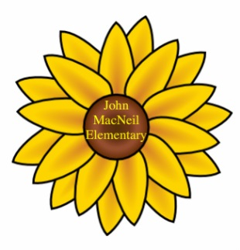
February 2021

http://jmc.hrsb.ca (902) 464-2488 @JohnMacNeil42

John MacNeil Elementary

February has arrived already. This month we celebrate Nova Scotian African Heritage. Please visit https://ansa.novascotia.ca/african-heritage-month for a list of resources that can help your family explore this province’s African Heritage.

We have already had changes in weather from snow to rain and back to snow again. Please make sure that your children are dressed appropriately for the weather. The winter weather may cause some closures, late starts or early dismissals. Please make sure to listen to the radio, check the HRCE website, twitter account, or sign up for text/email notifications.

Masks
All students in grade 3/4 and up must wear masks every day. We have many students that forget their masks at home quite often. We do not have enough masks to give out to every student every day. Families need to come up with a plan to help students and parents to remember. Suggestions are to always have an extra mask in their book bag and replace when used; have a spot right by the door where masks can be stored; put a post it on the back of your door to remind you.

Student Arrival
Students can enter the building between 8:20 and 8:40 each morning. Teachers will be waiting at their classroom doors to welcome students in. Please ensure your child is on time to limit disruptions and give your child the best opportunity to learn without missing important daily start up routines. With the colder weather now the doors may be shut. Just knock on the door and they will open it.

Student Dismissal
All students are dismissed at 2:45. It is unacceptable to pick up your child early every day. This disrupts not only your child’s day but every child in the class. The last 15-20 mins of the day are very important. Please arrive at 2:45 to pick up your child at their door, and please be patient as they are coming out of the school.

Primary and Pre Primary Registration
Just a reminder that Registration starts this month for the next school year. All new primary students must 5 by December 31st and pre primary students must be 4 by December 31^{st.} Please share this information with friends that have children who will be starting school in September. You can go online to fill out the registration forms https://www.hrce.ca/registration. If you already have a student here at John MacNeil we can send forms home to you. Due to Covid-19, non-essential visitors are not permitted to visit schools. Please email or send copies of the supporting documents needed for registration. If this is not possible please call the office 902-464-2488.

Important Dates

- Feb 15 – Edward Francis Arab Day (no classes, school is closed)
- March 15-19 - March Break

