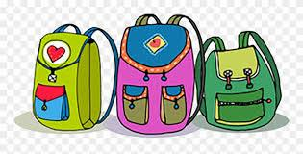
Primary Supply List
- 2 Packages of Primary Printing Pencils (large red/blue/or yellow)
- 8 Boxes 24 crayons
- 2 Packages of 8 broad tip markers (Please Label)
- 8 Large glue sticks
- 1 Bottle of white glue (Please Label)
- 3 Plastic Pocket folders (1 red, 1 blue, 1 black)
- 4 White erasers
- 1 Pair of scissors (Please Label)
- 2 Yellow Hilroy half lined/half blank book (Please label)
- 1 Pencil box (please label)
- 1 Package of white board markers (any colour)
- Indoor sneakers (Please Label)
Optional
Kleenex Box
2 large Ziploc bags
1 Sharper with attached bottom to hold pencil shavings

